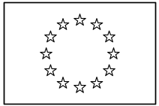 | EUROPEAN COMMISSION  DIRECTORATE-GENERAL  INFORMATICS  Information systems Directorate

European Commission
e-Trustex Use Case Specification: Submit Bundle Document

Date: | 13/01/2017
Version: | 1.001
Authors: | Anamaria BATRINU
Revised by: | Technical Review:  Quality Review:
Approved by:
Public:
Reference Number:

TABLE OF CONTENTS
1. Use-Case Description 3
2. References 3
3. Points of Extensions 3
3.1. Points of extension mapping 3
3.2. Document Type Code 4
3.3. Party Roles 4
3.4. Document Identifier 4
3.5. Document Issue Date 4
3.6. Synchronous XSD Validation 4
3.7. Synchronous Schematron Validation 4
3.8. Synchronous Specific Validation 5
3.8.1. Synchronous SLA Validation 5
3.8.2. Other specific validation 5
3.9. Synchronous Business Specific Processing 5
3.10. Asynchronous XSD Validation 5
3.11. Asynchronous Business Rules Validation 5
3.11.1. Asynchronous Schematron Validation 5
3.11.2. Asynchronous Parent-Child Relationship Validation 5
3.11.3. Reprocessing Timeframe for Parent Document 6
3.11.4. Asynchronous Specific Validation 6
3.12. Asynchronous Business Specific Processing 7
3.12.1. Human Readable Generation 7
3.12.2. SLA Policy Validation 7
3.12.3. Other specific processing 7
3.13. Availability Notification 7
3.14. State Machine 7
3.14.1. Transition to state Read 8
3.14.2. Transition to state Failed 8
3.15. Dispatching 8
4. Additional Information 8
4.1. Specific Exceptions 8
4.1.1. System perform Asynchronous Specific Validation and RULE387 fails 8
4.1.2. System perform Asynchronous Specific Validation and RULE274 fails 8
4.1.3. System perform SLA Policy Validation and the validation fails 8

Document History

Version | Date | Comment | Modified Pages
1.000 | 11/03/2015 | Creation | All
1.001 | 13/01/2017 | JIRA ETRUSTEX-2146 | Section 3.11.2 Asynchronous Parent-Child Relationship Validation

Use-Case Description
This Use Case describes the service that enables parties to send DocumentBundle document via electronic means using the e-TrustEx platform. It implements the Submit Document Template that extends the generic use case UC1_002 Process Asynchronous Message to DocumentBundle document.

References
Document Title | Document Reference
Submit Document Template | Version 2.005 of https://webgate.ec.europa.eu/CITnet/svn/ETRUSTEX/trunk/001%20e-TrustEx/002%20Requirements/Use%20Case%20Model/New%20Use%20Cases/Submit%20Document%20Template%20Use%20Case%20Specification_2.0.doc
UC1_002 Process Asynchronous Message | https://webgate.ec.europa.eu/CITnet/svn/ETRUSTEX/trunk/001 e-TrustEx/002 Requirements/Use Case Model/New Use Cases/UC1_002 Process Asynchronous Message.doc
Use Case eTrustex – Submit Application Response | https://webgate.ec.europa.eu/CITnet/svn/ETRUSTEX/trunk/001 e-TrustEx/002 Requirements/Use Case Model/UC1_4_1.Submit+Application+Response+Use+Case+Specification.docx
DocumentBundle XSD document | https://webgate.ec.europa.eu/CITnet/svn/ETRUSTEX/trunk/001 e-TrustEx/003 Architecture/001 Data Model/200 XSD/xsd/maindoc/EC-DocumentBundle-1.0.xsd
DocumentBundleSchematron rules document | https://webgate.ec.europa.eu/CITnet/svn/ETRUSTEX/trunk/001 e-TrustEx/003 Architecture/001 Data Model/200 XSD/schematron/DocumentBundle/DocumentBundle.sch
Code List Document | https://webgate.ec.europa.eu/CITnet/svn/ETRUSTEX/trunk/001 e-TrustEx/003 Architecture/001 Data Model/000 Code Tables/EC_CodeList_e-TrustEx.xls
Human Readable Template | To be defined.

Points of Extensions

Points of extension mapping
Point of extension (in this document) | Extended point (in Asynchronous Use Case)
Document Type Code | Point of extension 2  Point of extension 4  Point of extension 9
Party Roles | Point of extension 1
Document Identifier | Point of extension 3
Document Issue Date | Point of extension 8
Synchronous XSD Validation | Point of extension 5
Synchronous Schematron Validation | Point of extension 6
Synchronous Specific Validation | Point of extension 7
Synchronous Business Specific Processing | Point of extension 17
Asynchronous XSD Validation | Point of extension 10
Asynchronous Schematron Validation | Point of extension 11
Asynchronous Parent-Child Relationship Validation | Point of extension 12
Reprocessing Timeframe | Point of extension 16
Asynchronous Specific ValidationError: Reference source not found | Point of extension 18
Data Extraction | Point of extension 13
Asynchronous Business Specific Processing | Point of extension 14
Availability Notification | Point of extension 19
Dispatching | Point of extension 15

Document Type Code
The document type code for DocumentBundle is BDL and it is defined in Code List Document, under the sheet DocumentTypeCode.

Party Roles
The DocumentBundle document must be sent by a Party having BundleExchanger Role and received by a Party having BundleExchanger Role.

Document Identifier
The document identifier can be found via the following Xpath expression:
\\DocumentBundle\cbc:ID

Document Issue Date
The document issue date can be found via the following Xpath expression:
\\ DocumentBundle \cbc:IssueDate

Synchronous XSD Validation
N/A

Synchronous Schematron Validation
N/A

Synchronous Specific Validation

Synchronous SLA Validation
N/A

Other specific validation
N/A

Synchronous Business Specific Processing
System performs the following synchronous business processing:
N/A

Asynchronous XSD Validation
The document must be valid according to XSD documentDocumentBundle.

Asynchronous Business Rules Validation

Asynchronous Schematron Validation
The document must be valid according to the following set of rules implemented in the Schematron documentDocumentBundle:
ID | Description | Element path | Severity | Category | Subcategory
RULE269/RRC18532 | ParentDocumentTypeCode must be of the same type as the document type | DocumentBundle.ParentDocumentTypeCode | Hard | Message content check | Codelist validation
RULE270/RRC18538 | ParentDocumentID string length is at most 250 characters | DocumentBundle.ParentDocumentID | Hard | Message content check | Constraint validation
RULE271/RRC18527 | ParentDocumentID is allowed only characters from the 7-bit ASCII table | DocumentBundle.ParentDocumentID | Hard | Message content check | Constraint validation
RULE272/RRC18535 | IssueDate is not in the future | DocumentBundle.IssueDate | Soft | Message content check | Message logic
RULE273/RRC18530 | IssueDate is not older than 12 months | DocumentBundle.IssueDate | Soft | Message content check | Message logic

Asynchronous Parent-Child Relationship Validation
The parent document, if it exists, must be valid according to the following specific rules which complete the parent-child validation rules described in the asynchronous use case:
ID | Description | Element path | Severity | Category | Subcategory
RULE275/RRC18539 | ParentDocumentID must already exist in the system with the same ParentDocumentTypeCode |  | Hard | External check | Parent ID validation
RULE290/RRC18534 | For standard parent validation: The SenderParty of the parent document must be equal to the SenderParty OR ReceiverParty of the document (both found in the header) |  | Hard | External check | Parent ID validation
RULE291/RRC18529 | For standard parent validation: The ReceiverParty of the parent document must be equal to the ReceiverParty OR SenderParty of the document (both found in the header). |  | Hard | External check | Parent ID validation
RRC49996 | For parent validation of child messages sent from the receiver to a different party than the original sender: The SenderParty of the parent document must be equal to the OriginalSenderParty (specified in the message payload). | /DocumentBundle/cac:OriginalSenderParty/cbc:EndpointID | Hard | External check | Parent ID validation
RRC49997 | For parent validation of child messages sent from the receiver to a different party than the original sender: The ReceiverParty of the parent document must be equal to the SenderParty of the document (specified in the header). |  | Hard | External check | Parent ID validation

Reprocessing Timeframe for Parent Document
The reprocessing of the message is done during the following timeframe:
The policy to apply when no parent document is found is ERROR. Thus no reprocessing timeframe is configured.

Asynchronous Specific Validation
The document must be valid according to the following specific rules:
ID | Description | Element path | Severity | Category | Subcategory
RULE387/RRC18536 | DocumentWrapperReference must be unique within the message (according to ID and DocumentTypeCode) | N/A | Hard | Message body check | Payload type
RULE274/RRC18533 | DocumentWrapperReference.ID must point to an existing Document Wrapper (according to the ID and the DocumentTypeCode).  This validation occurs for all the instances of DocumentReference within the message. | N/A | Hard | Message body check | Payload type

Asynchronous Business Specific Processing

Human Readable Generation
N/A

SLA Policy Validation
The message must be valid according to the following SLA policy configurations:
ID | Description | Element path | Severity | Category | Subcategory
RULE597 | The number of wrappers in the bundle does not exceed the maximum allowed. |  | Hard | Message content check

Other specific processing
System might perform other specific processing:
N/A

Availability Notification
The available notification can be found via the following Xpath expression:
//*:BusinessHeader/*:BusinessScope/*:Scope/*:ScopeAttributes/*:Type

State Machine
The following state machine shows the usual (generic) states that are Submitted, Received and Error. Beside these states some specific states are displayed in blue: Approved and Rejected.

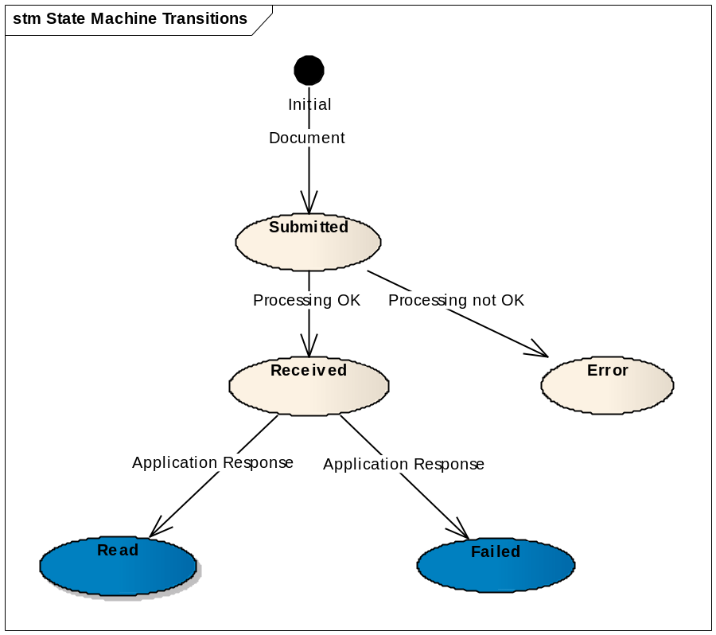

Transition to state Read
At this point, the Use Case Submit Application Response is included.
When an application response referencing an existing DocumentBundle document in state received arrives in the system with a response code BDL:7 the state of the DocumentBundle document becomes Read.

Transition to state Failed
At this point, the Use Case Submit Application Response is included.
When an application response referencing an existing DocumentBundle document in state received arrives in the system with a response code BDL:4 the state of the DocumentBundle document becomes Failed.

Dispatching
The following routing rules are used for dispatching the message:
Not a general rule for bundle, there are specific routing configuration for bundles that are using certain parties, interchange agreements etc. depending on the business need.

Additional Information

Specific Exceptions
The exceptions described here below complete the list of business exceptions in the section 3.3.2 Asynchronous Exceptional Flow from UC1_002 Process Asynchronous Message and follow the same pattern.

System perform Asynchronous Specific Validation and RULE387 fails
- DCT:D = BDL:4
- Error description = Hard business rule violated

System perform Asynchronous Specific Validation and RULE274 fails
- DCT:D = BDL:6
- Error description = Missing Attachment binary data

System perform SLA Policy Validation and the validation fails
- DCT:D = BDL:4
- Error description = Hard business rule violated

